Project Name: |  | Company:
Meeting Date: |  | Name: | Repeat Call: Y/N Date of first meeting:
Month/Day/Year |  | Month/Day/Year
Handled by: |  | Location:

Customer Technical Requirements
Technical Considerations: Fluid Characteristics | Description/Explanation of Customer input | MPV Product Engineering Response
- What is the application?
- What is the fluid?
- What specific corrosion fluid concerns are there?
- What is the fluid temperature range? (nominal, min, max)
- What is ambient temperature range? (nominal, min, max)
- What is the base solvent?
- Does the fluid contain particles? If so, what is the particulate loading (% by weight) of fluid and what is the size and concentration?
- What is the viscosity?
Technical Considerations: System Requirements | Description/Explanation of Customer input | MPV Product Engineering Response
- What is the flow or flow range? (nominal, min, max)
- What are the accuracy requirements? (+/- flow %)
- What is the differential pressure or pressure range? (nominal, min, max)
- What is the inlet pressure range?
- What is the maximum system pressure?
- What is the wet lift? / Dry lift? (meters)
- What is the inlet and outlet tubing ID and length?
Technical Considerations: Mechanical Requirements | Description/Explanation of Customer input | MPV Product Engineering Response
- Are there any leak containment requirements?
- Are there noise constraints? What are they? (dB)
- Are there size constraints? What are they?
- What is the expected duty cycle? (Continuous? Intermittent percent? Number of shifts per day or week?)
- How do they want to attach the pump? Can they provide dimensions/drawings?
- How do they want to attach the fluid connection? Can they provide dimensions/drawings?
- What is the expected life of the pump?
- Are there any environmental considerations? (ingress protection)
Technical Considerations: Electrical Requirements | Description/Explanation of Customer input | MPV Product Engineering Response
- What are the drive considerations for the pump? (brushless DC, integrated drive, stator only or pump head only)
- What are the power considerations? (input voltage, current and control method)
Technical Considerations: Regulatory and Safety Requirements | Description/Explanation of Customer input | MPV Product Engineering Response
- Are there any regulatory requirements? (refer to specific standards, etc.)
- Are there any safety requirements?
Customer Commercial Information
Market Considerations | Description/Explanation of Customer input | MPV Commercial Response
- What is the customer’s market segment(s) focus?
- Market size of this opportunity?
- What is this market segment growth rate expectation?
- Who are Micropump’s competitors?
- Identified barriers to entry?
- Who are the customer’s competitors?
- What is the customer’s project schedule and milestones?

Pricing Considerations | Description/Explanation of Customer input |  | MPV Commercial Response
Pricing Considerations | Cost | Sell Price | Sell Price Information
- What is the target set by the customer? | N/A
- Estimated targets set by Micropump Sales? | N/A
- Customer Estimated Machine sales price?

Customer Considerations | Description/Explanation of Customer input | MPV Commercial Response
- What are the customer’s quality system requirements?
- What are the customer’s quality expectations?

Competitive Environment | Description/Explanation of Customer input | MPV Commercial Response
- Who are the potential competitors?
- What type of product is supplied by competitor?
- What is the expected competitive advantage for MP?

Additional Comments
Topic | Description/Explanation of Customer input | MPV Commercial Response
- What are the key project risks?
- Is there any other pump or pumping technologies used in your system?
** Expectation is to fill in the data with known facts

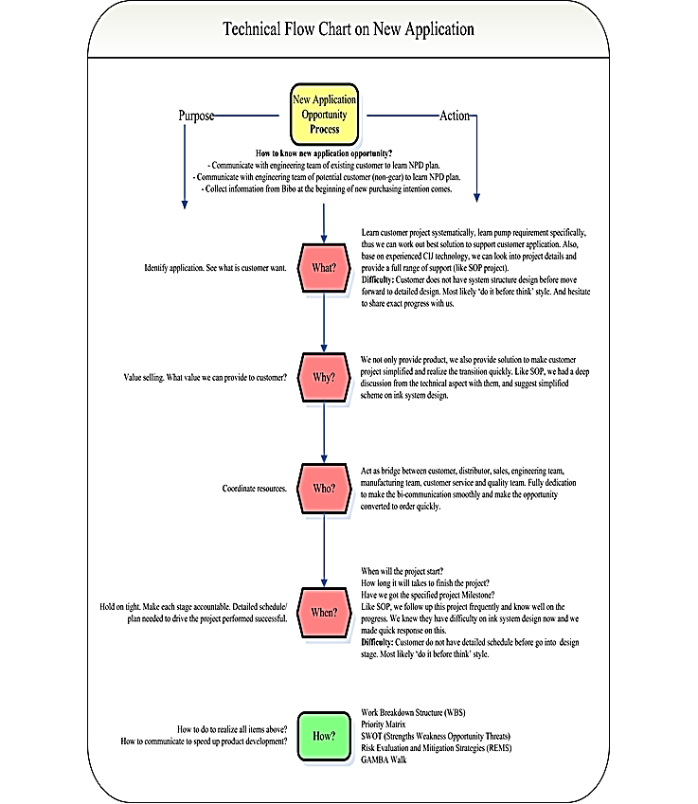
NOTES:

